Title: When Quantum System<s Go Haywire: Exploring Nonequilibrium Phase Transitions

**N. N. Surname1,2, N. Surname2, N. Surname3, N. Surname3,4, N. Surname2, N. Surname4, N. Surname3, N. Surname2, N. Surname1, N. Surname1, N. Surname2**

1 First insitution, City, Country

2 First insitution, City, Country

3 First insitution, City, Country

4 First insitution, City, Country

The abstract should not exceed one page.

Disclaimer: This text was conjured by an AI with a penchant for quantum poetry and a mild obsession with femtoseconds. Interpret with curiosity, not commitment. [1]

When quantum systems are nudged, poked, or blasted by ultrafast lasers, they tend to misbehave—in the most illuminating ways. Nonequilibrium phase transitions emerge not from quiet contemplation, but from chaos: sudden perturbations in temperature, pressure, magnetic fields, or photon flux that coax matter into exotic states it never knew it could inhabit.

From the laser-induced vanishing act of magnetic order to the spontaneous birth of coherence in ultracold atoms, these transitions defy equilibrium logic and challenge our theoretical toolkits. Ergodicity? Sometimes it takes a coffee break. Thermalization? Not always RSVP-ing. And yet, with pump-probe setups, time-resolved scattering, and a dash of quantum field theory, we chase these fleeting states across the femtosecond frontier.

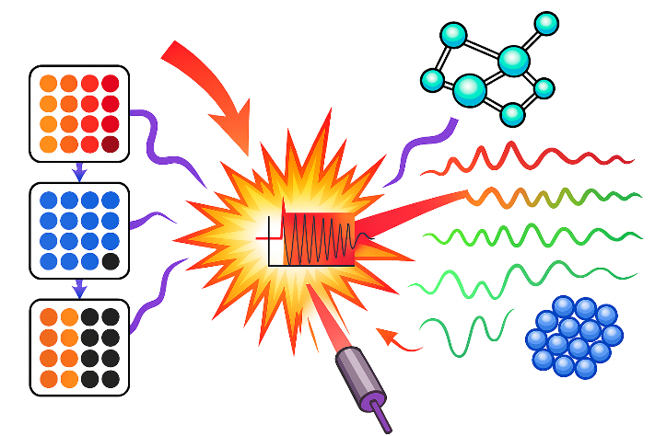So if your system refuses to sit still, congratulations—you might be onto something. Welcome to the wild side of matter, where disorder breeds insight and equilibrium is just a polite suggestion. [2]

Figure : Quantum systems going haywire (strictly in nonequilibrium) in style. This conceptual illustration depicts a quantum material struck by an ultrafast laser pulse, triggering a cascade of nonequilibrium phenomena.

|  |  |
| --- | --- |
| [1] | Author 1, Title 1, City 1: Publisher 1, Year 1. |
| [2] | Author 2, Title 2, City 2: Publisher 2, Year 2. |